**The Government of Japan**

**PROGRAM OF ASSISTANCE TO COMMUNITY AND HUMAN SECURITY PROJECTS (APC)**

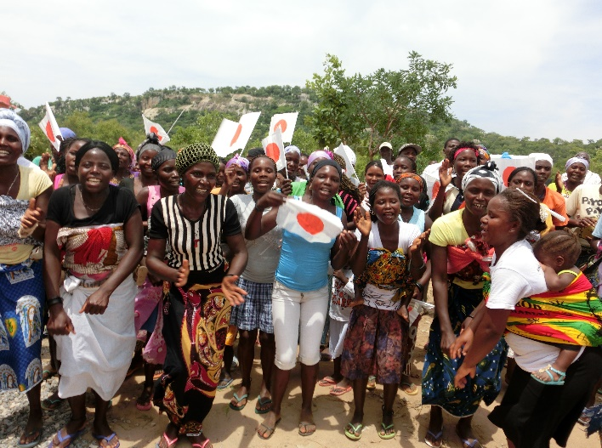**APC 2025 Application Guide**

1. **OBJECTIVE**
2. **QUALIFIED ORGANIZATIONS**
3. **TIPE OF PROJECTS**
4. **ITEMS NOT COVERED**
5. **AMOUNT OF GRANT**
6. **HOW TO APPLY**
7. **REQUIRED DOCUMENTS**
8. **OTHER REQUIREMENTS**
9. **PROCESS FOR APPROVAL**

**※SEPARATE FORM**

EMBASSY OF JAPAN IN ANGOLA

1. Objective

The APC Program provides non-refundable financial assistance to Non-Governmental organizations (NGOs), Local Government Institutions (at prefectural and municipal level) and other non-profit Social Institutions in order to help implement their development projects. The APC grant, available for 143 countries and regions (2024), provide Japan’s Official Development Assistance (ODA) with new means of cooperation that directly influence the well-being of communities.

1. Qualified Organizations

All non-profit organizations can be beneficiaries of the APC, as long as they are focused on implementing community projects (individual projects and profit-oriented institutions are not subject to this program)

Such as:

* NGOs (local and international);
* Local government institutions (provincial and municipal);
* Public health establishments;
* Public schools;

[Minimum criteria]

1. Be registered by The Ministry of Social Action, Family and Promotion of Women (the former IPROCAC units)
2. Submit a copy of the Public Utility Statute and the publication in the “Diário da República”.
3. Have at least 2 (two) years experience in the activity to be proposed.
4. Type of Projects

Any development project aimed at community assistance can be financed through the APC. However, priority is given to projects to improve basic human needs, such as;

* Health sector (ex: construction of health centers, installation of hospital medical equipment, nutrition, preventive and curative health;) ※Regarding health-related project, applicants must be the provincial government or the local institution.
* Education sector (ex: construction of elementary school, provision of school materials, general education, vocational training;)
* Agriculture sector (ex: formation of agricultural associations, distribution of seeds, agricultural tools and fertilizers and food safety;)
* Social Assistance sector (ex: support for mine victims, widows and orphans, water and sanitation;).

1. Items **cannot** be covered by APC program

Potential applicants should be aware that the following budget items cannot be covered.

* Consumable materials (except in the case of emergency humanitarian aid or essentially necessary for some kind of training;)
* Administrative and operational costs of the NGO or implementing institution itself, including the cost of purchasing equipment (e.g. computers, copiers, projectors and their installation and maintenance).
* Costs for human resources (Such as cleaners, guards, drivers, accountants, secretaries..) and transport for the staff of the implementing organization (except coordinators, technical specialists, multipliers and/or instructors specifically needed for the project and only during the implementation of the project;
* Land acquisition
* Rent for the NGO’s office
* Expenses for the acquisition of legal documents
* Purchase of vehicles (except: fire engines, ambulances, school bus…)
* Bank charges
* Any type of tax etc.
* Research and scholarships
* Vaccinations
* School and academic books
* Snacks or food

1. Amount of Grant

APC grants are given annually to organizations/institutions after each project has been evaluated and approved by the Japanese government. The amount of a grant per project is 15 million yen (Japanese currency), approximately USD107,000 (One hundred and seven thousand US dollars). We strongly recommend that organizations budget for the project based on the needs.

1. How to Apply

Potential applicants may submit the specific form attached to this guide between **November 2024** and **February 2025.** Although late submissions are acceptable, the priority of selection will be given to projects within the said deadline.

E-mail: [japaoapc@ln.mofa.go.jp](mailto:japaoapc@ln.mofa.go.jp) Phone: 923-167-090

1. Required Documents

For the selection and approval of the proposed project, the applicant organization/institution must attach at least the following documents to the specific application form.

1. Budget plan for the proposed project
2. Implementation plan (In table form, and in monthly sequence with the activities to be carried out 1 year or less.).
3. Geographical map of the location where the project will be implemented.
4. Technical drawing (Blue print, foundation plan with details, elevations and water and sewage details), if it is a construction project.
5. Quotes/Proforma invoices from THREE suppliers specifying the value of the services and materials required for the project, if it is a construction project or provision of device (e.g.: school bus, motor pump etc..).
6. Copy of the document which is registered by MASFAMU or IPROCAC (UTACH) and the “Diário da República” of the applicant organization
7. Letter of recognition and permission of the project proposed by the public institution.
8. Documents presenting your organization, such as brochures or other printed materials.

NOTE: For further clarifications about submissions, please refer to the specific application form.

1. Other requirements

* The grant received must be used only for the approved project. The Japanese diplomatic mission reserves the right to demand the return of the grant if it is used for purposes unrelated to the implementation of the approved project.
* In order to facilitate auditing operations by the Japanese diplomatic mission or its representative, the beneficiary organization must establish an exclusive account for the approved project.

1. Process for Approval

Use the Specified format

Required Submissions

・Request for payment

・Monthly report

・interim report

・final report

・Audit report

※Deadline

**From November 2024 to February 2025**